**Course _______Specialist_____ Year ___12_____**

Student name: ________________ Teacher name: ________________

**Task type: Response**

**Time allowed for this task: ____40_______ mins**

**Number of questions: _____7______**

**Materials required:** Calculator with CAS capability (to be provided by the student)

Standard items: Pens (blue/black preferred), pencils (including coloured), sharpener, correction fluid/tape, eraser, ruler, highlighters

Special items: Drawing instruments, templates, notes on one unfolded sheet of   
A4 paper, and up to three calculators approved for use in the WACE examinations

**Marks available: ___38___ marks**

**Task weighting: _10___%**

**Formula sheet provided: Yes**

**Note: All part questions worth more than 2 marks require working to obtain full marks.**

Q1 (2, 2 & 3 = 7 marks) (3.1.1 to 3.1.3)

If  &  determine the following.

1. 

|  |
| --- |
| **Solution** |
|  |
| **Specific behaviours** |
| 🗸 shows conjugate of z  🗸 obtains result |

1. 

|  |
| --- |
| **Solution** |
|  |
| **Specific behaviours** |
| 🗸 uses conjugate  🗸 obtains simplified result |

1. 

|  |
| --- |
| **Solution** |
|  |
| **Specific behaviours** |
| 🗸 expresses one fraction with real denominator showing use of conjugates  🗸 expresses both fractions with real denominators showing use of conjugates  🗸 simplified result  (answer only one mark) |

Q2 (3 marks) (3.1.2)

Determine all possible pairs of real numbers  such that 

|  |
| --- |
| **Solution** |
|  |
| **Specific behaviours** |
| 🗸 obtains one equation for a & b  🗸 states two simultaneous equations and solves for at least one pair  🗸 states two pairs of values |

Q3 (2 & 3 = 5 marks) (3.1.13- 3.1.15)

Consider the function .

1. Determine the remainder of  when divided by .

|  |
| --- |
| 1. **Solution** |
|  |
| **Specific behaviours** |
| 🗸 subs x=5  🗸 states zero remainder |

1. Show that  is a factor of and hence determine all linear factors.

|  |
| --- |
| **Solution** |
|  |
| **Specific behaviours** |
| 🗸 subs x=3i and shows the result of **each** term with the sum being zero  🗸 uses conjugate root stating two complex linear factors  🗸 states all 3 linear factors |

Q4 (3 marks) (3.1.9)

Determine the complex number  in the form  with  & .

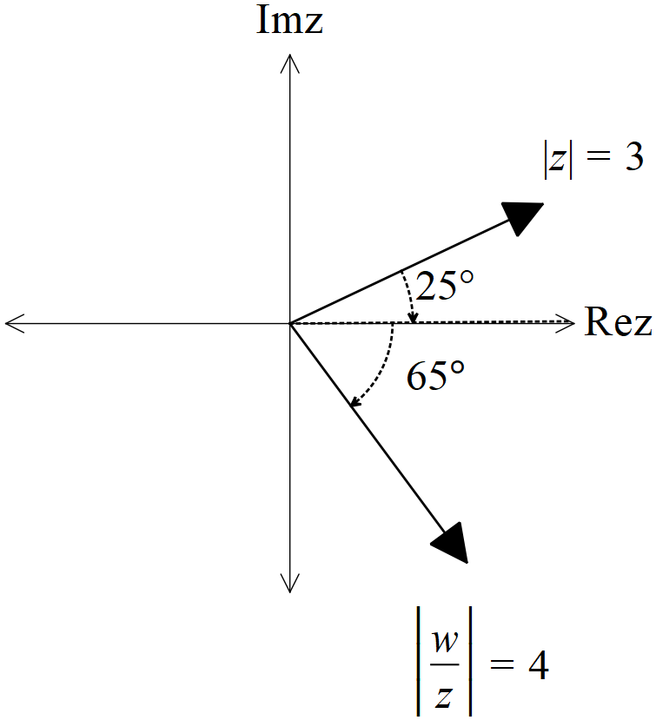

|  |
| --- |
| **Solution** |
|  |
| **Specific behaviours** |
| 🗸 determines argument with working  🗸 states modulus  🗸 states in polar form with principal argument |

Q5 (2, 2, 3 & 3 = 10 marks) (3.1.10)

Consider the following set of complex numbers  such that .

Determine the following.

1. Minimum value of .(exact)

|  |
| --- |
| **Solution** |
|  |
| **Specific behaviours** |
| 🗸 uses modulus of centre  🗸 states exact value |

1. Maximum value of .

|  |
| --- |
| **Solution** |
|  |
| **Specific behaviours** |
| 🗸 uses modulus of centre and ignores conjugate  🗸 states exact value |

1. Maximum value of Arg in radians to two decimal places.

|  |
| --- |
| **Solution** |
|  |
| **Specific behaviours** |
| 🗸 uses tangent line and finds argument of centre  🗸 uses inverse sine to find added argument to tangent  🗸 states argument rounded to 2 dp radians |

1. Maximum value of  (exact)

|  |
| --- |
| **Solution** |
|  |
| **Specific behaviours** |
| 🗸 use distance from -3 on real axis  🗸 determine distance to centre from -3  🗸 adds radius to give maximum distance |

Q6 (3 & 3 = 6 marks) (3.1.6)

Let  be complex numbers such that



1. Determine the exact value of Arg() in principal form (i.e )

|  |
| --- |
| **Solution** |
|  |
| **Specific behaviours** |
| 🗸 multiplies Arg(p) by 5  🗸 determines argument of q  🗸 determines final principal argument of s |

1. Determine the exact value of 

|  |
| --- |
| **Solution** |
|  |
| **Specific behaviours** |
| 🗸 raises mod of p to power of 5  🗸 determines mod of both terms in denominator  🗸 determines exact result |

Q7 (4 marks) (3.1.10)

Sketch the locus of complex numbers that satisfy **both** of the following

 **AND**  in the Argand diagram below.

|  |
| --- |
| **Solution** |
|  |
| **Specific behaviours** |
| 🗸 uses line that when extended passes through -2 on imaginary axis (dotted)  🗸 has line passing through 3 on real axis  🗸 only allows part of line above real axis  🗸 shows that line only has a length of 5 units |